
RAMAIAH
Institute of Technology
USN | 1 | M | S

(Autonomous Institute, Affiliated to VTU)
(Approved by AICTE, New Delhi & Govt. of Karnataka) Accredited by NBA & NAAC with ‘A’ Grade

SUPPLEMENTARY SEMESTER EXAMINATIONS – JULY/AUGUST 2018

Course & Branch | : | B.E. : Computer Science and  Engineering | Semester | : | IV
Subject | : | Engineering Mathematics - IV | Max. Marks | : | 100
Subject Code | : | CS41 | Duration | : | 3 Hrs

Instructions to the Candidates:
- Answer one full question from each unit.

 |  | UNIT- I
1. | a) | Write Lagrange’s inverse interpolation formula. | CO1 | (02)
 | b) | Solve the equation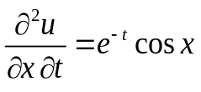, given that 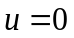when 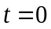 and 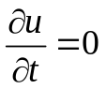at . | CO1 | (04)
 | c) | Using Newton's divided difference formula, representas a polynomial inand hence find 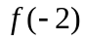. | CO1 | (07)
   | -4 | -1 | 0 | 2 | 5
   | 1245 | 33 | 5 | 9 | 1335
 | d) | The velocity of a particle at distance from a point on its path is given by the following table. Estimate the time taken to travel 60 ft by using Simpson’s 1/3rd rule. | CO1 | (07)
  (ft) | 0 | 10 | 20 | 30 | 40 | 50 | 60
  (ft/s) | 47 | 58 | 64 | 65 | 61 | 52 | 38
2. | a) | Write the formulae to find 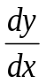and 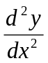 using Newton-Gregory forward interpolation formula when is not a specified value. | CO1 | (02)
 | b) | Find 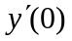and 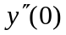form the following table: | CO1 | (04)
   | 0 | 1 | 2 | 3
   | 1 | 3 | 7 | 13
 | c) | The following table gives the population of a city in Lakhs during the last five censuses. Estimate the increase in the population during  the period from 1945 to 1975. | CO1 | (07)
  Years () | 1941 | 1951 | 1961 | 1971 | 1981
  Population () | 12 | 15 | 20 | 27 | 39
 | d) | Solve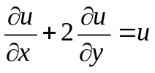, given that 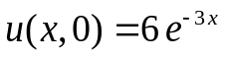by the method of separation of variables. | CO1 | (07)
 |  | UNIT- II
3. | a) | Define continuous Random variable with an example. | CO2 | (02)
 | b) | Find the variance of the binomial distribution. | CO2 | (04)
 | c) | Define uniform distribution. If a random variable k is uniformly distributed over (0,5), what is the probability that the roots of the equation 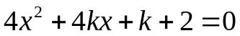 are real. | CO2 | (07)
 | d) | A random variable X has the following probability mass function for various values of x  Find (i) k (ii) standard deviation (iii) P(|2x -2|>3). | CO2 | (07)
  x: | -5 | -2 | -1 | 0 | 2 | 4 | 6 | 7
  y: | 0 | k | 2k | 2k | 3k | k² | 2k² | 7k²+k
4. | a) | Define Poisson distribution and write its mean and variance. | CO2 | (02)
 | b) | The length of telephone conversation in a booth has been an exponential distribution and found on average to be 5 minutes. Find the probability that a random call mode from this booth (i) end less than 5 minutes (ii) between 5 and 10 minutes. | CO2 | (04)
 | c) | The life of a certain type of electrical lamps in normally distributed with mean 2040 hours and standard deviation 60 hours. In a consignment of 3000 lamps, how many would be expected to burn for (i) more than 2150 hours (ii) less than 1950 hours and (iii) between 1920 and 2160 hours. | CO2 | (07)
 | d) | The probability density p(x) of a continuous random variable is given by 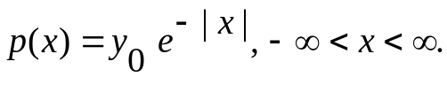 Prove that 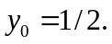 Find the mean and variance of the distribution. | CO2 | (07)
 |  | UNIT- III
5. | a) | Define joint probability distribution of X and Y in discrete case. | CO3 | (02)
 | b) | Find the auto correlation R(t₁, t₂) of the stochastic process defined by 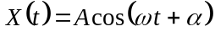 where the random variables and are independent and is uniform in the interval 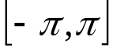. | CO3 | (04)
 | c) | A fair coin is tossed three times. Let X denote 0 or 1 according as a head or tail occurs on the first toss. Let Y denote the number of heads which occur. (i) Find the marginal distributions of X and Y, (ii) Determine the joint distribution of X and Y and (iii) Cov (X,Y). | CO3 | (07)
 | d) | Show that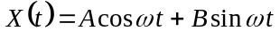, where and are uncorrelated random variables each with mean 0 and variance 1 and is a positive constant is a WSS. | CO3 | (07)
6. | a) | Define:  (i) Auto correlation (ii) Ergodicity. | CO3 | (02)
 | b) | A random process X(t) is represented by the ensemble {-k, -2k, -3k, k, 2k, 3k}, (k > 0) corresponding to the outcomes of an event which are equally probable. Show that the random process is SSS but not WSS. | CO3 | (04)
 | c) | If X and Y are continuous random variables having the joint density function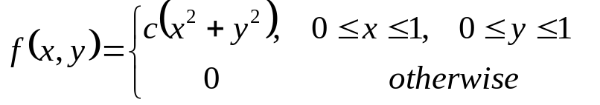.  Find:  - the value of c  - 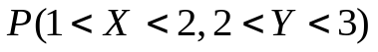  - 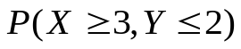  - Find the marginal pdf of X and Y (v) Are X and Y independent. | CO3 | (07)
 | d) | A stochastic process with its ensemble functions are assumed to have equal probabilities are given by:  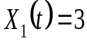,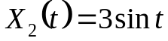, 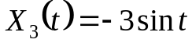, 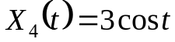, 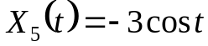,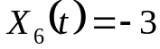. Show that the process is WSS but not SSS. | CO3 | (07)
 |  | UNIT- IV
7. | a) | Define Absorbing state with an example. | CO4 | (02)
 | b) | A TV repairman finds that the average time spent on a job is 30 minutes. If he repairs sets in the order in which they come in and if the average arrival of sets is 10 per 8 hour-day, what is the repairman’s expected idle time each day? | CO4 | (04)
 | c) | A player has Rs. 300. At each play of a game he losses Rs. 100 with probability ¾ but wins Rs. 200 with probability ¼. He stops playing if he lost Rs. 300 or he has won atleast Rs. 300. Find (i) transition probability matrix (ii) there are atleast 4 plays to the game. | CO4 | (07)
 | d) | In a self-service store with one cashier, 8 customers arrive on an average of every 5 min and the cashier can serve 10 in 5 min. If both arrival and service time are exponentially distributed then determine : (i) average number of customer waiting in the queue for service. (ii) expected waiting in the queue. (iii) What is the probability of having more than 6 customers in the system? | CO4 | (07)
8. | a) | Define M|M|1 Queuing model. | CO4 | (02)
 | b) | Find the fixed probability vector of the matrix:  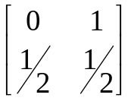 | CO4 | (04)
 | c) | There are 2 white marbles in bag A and 4 red marbles in bag B. At each step of the process a marble is selected at random from each bag and the two marbles selected are interchanged then find (i) transition probability matrix (ii) what is the probability that there are 2 red marbles in A after 3 steps; (iii) In the long run what is the probability that there are 2 red marbles in A? | CO4 | (07)
 | d) | In a heavy machine shop, the overhead crane is utilized 75%. The study observation gave the average service time as 10.5 min with a standard deviation of 8.8 min. (i) What is the average calling rate for the services of the crane? (ii) What is the average delay in getting the service? (iii) If the average service time is cut to 8 min and the S.D. is 6 min. How much reduction will occur on an average in delay of getting service? | CO4 | (07)
 |  | UNIT- V
9. | a) | Define Type-I and Type – II errors. | CO5 | (02)
 | b) | A machanist is making engine parts with axle diameter of 0.7 inch. A random sample of 10 parts shows mean diameter 0.742 inch with a Standard deviation of 0.04inch .On the basis of the sample, would you say that the work is inferior? | CO5 | (04)
 | c) | The following data represents the biological values of protein from cow’s milk and buffalo’s milk at a certain level.  Examine if the average values of protein in the two samples significantly differ. | CO5 | (07)
  Cow’s milk | 19 | 17 | 15 | 21 | 16 | 18 | 16 | 14
  buffalo’s milk | 15 | 14 | 15 | 19 | 15 | 18 | 16 | ---
 | d) | Fit a Poisson distribution for the following data and test the goodness of fit. | CO5 | (07)
  x | 0 | 1 | 2 | 3 | 4 | 5 | 6
  f | 273 | 70 | 30 | 7 | 7 | 2 | 1
10. | a) | Define null hypothesis and alternate hypothesis. | CO5 | (02)
 | b) | A bag contains three tickers numbered 1, 3 and 5. Two tickets are drawn at random one after the other with replacement. List all possible samples of size 2. Show that (i) mean of population = mean of sample (ii) sample S.D. = 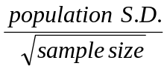 | CO5 | (04)
 | c) | Two samples of sizes 9 and 8 gave the sums of squares of deviations from their respective means equal to 160 and 91 respectively. Can they be regarded as drawn from the same normal population? | CO5 | (07)
 | d) | The following data relate to the marks obtained by 8 students in 2 tests, one held at the beginning of a year and the other at the end of a year after intensive coaching.  Do the data indicate that the students have benefitted by coaching? | CO5 | (07)
  Test 1 | 19 | 23 | 16 | 24 | 17 | 18 | 20 | 18
  Test 2 | 17 | 24 | 20 | 24 | 20 | 22 | 20 | 20

****************

